SUNDAY | MONDAY | TUESDAY | WEDNESDAY | THURSDAY | FRIDAY | SATURDAY
1 10:15 Sandbag Toss  1:00 Communion  1:30 Mental Aerobics  2:30 Church | 2 9:30 Decorate for Thanksgiving  1:30 Video Memories  3:15 Point / Counterpoint  4:00 Never Have I Ever… | 3 Massage  10:15 Exercise  11:00 Carpet Bowling  1:30 Walk & Roll  3:00 Readings  4:00 Crosswords | 4 9:30 Fifth Avenue Jewelry  10:00 Make Fall Centerpieces  2:30 Birthday Party with Barry Powel  7:00 Bingo | 5 10:15 Exercise  11:00 Carpet Bowling  1:30 Reno Keno  2:30 Tai Chi  4:00 Current Affairs | 6 Mad Hatter Day  10:00 Dr. Jassal - Optometrist  1:30 Noodle Hockey  2:30 Happy Hour  4:00 My Bio | 7  10:15 Exercise  11:00 Carpet Bowling  2:00 Left Right Center  7:00 Bingo
8 10:15 Sandbag Toss  1:00 Communion  1:30 Mental Aerobics  2:30 Church | 9 Thanksgiving  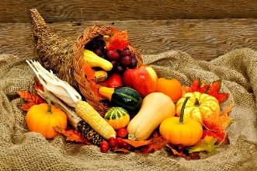 | 10 Massage  10:15 Exercise  11:00 Carpet Bowling  1:30 Walk & Roll  3:00 Readings  4:00 Mental Aerobics | 119:00 Neighbourhood Walk  9:45 Decorate for Halloween  2:00 Painting  4:00 Relax Colouring  7:00 Bingo | 12 10:15 Exercise  11:00 Carpet Bowling  1:30 Reno Keno  2:30 Tai Chi  4:00 Current Affairs | 13 10:15 Mental Aerobics  10:30 Communion  11:30 Lunch at Espresso Café  2:30 Happy Hour  4:00 Journaling My Bio | 14  10:15 Exercise  11:00 Carpet Bowling  2:00 Left Right Center  7:00 Bingo
15 10:15 Sandbag Toss  1:30 Mental Aerobics  2:30 Church | 16 DICTIONARY DAY  9:45 Walmart – Whiterock  2:30 Video Memories  3:45 Point / Counterpoint  3:30 Resonate with Joy | 17 Massage  10:15 Exercise  11:00 Carpet Bowling  1:30 Walk & Roll  3:00 Readings  4:00 Mental Aerobics | 18 9:00 Absolute Hearing  10:00 Health Corner with Brigita - Eyes  1:30 Fall Centerpieces  4:00 Relax Colouring  7:00 Bingo | 19 10:15 Exercise  11:00 Carpet Bowling  1:30 Reno Keno  2:30 Tai Chi  4:00 Current Affairs | 20 8:30 Bus Trip – Scenic Drive Manning Park  1:30 Noodle Hockey  2:30 Happy Hour | 21  10:15 Exercise  11:00 Carpet Bowling  2:00 Left Right Center  7:00 Bingo
22 10:15 Sandbag Toss  1:00 Communion  1:30 Mental Aerobics  2:30 Church | 23 10:45 Lunch at the Golden Panda  2:00 Video Memories  3:30 Point / Counterpoint  4:00 What Year Was This?… | 24  10:15 Exercise  11:00 Carpet Bowling  1:30 Walk & Roll  3:00 Readings  4:00 Mental Aerobics | 25 9:45 Coffee Klatch  11:00 C-Lovers in Langley  3:15 Relax Colouring  7:00 Bingo | 26 10:15 Exercise  11:00 Carpet Bowling  1:30 Reno Keno  2:30 Tai Chi  4:00 Current Affairs | 27 1:30 Noodle Hockey  2:30 Happy Hour with Carl  4:00 Journaling My Bio  7:30 Red Skelton Show | 28  10:15 Exercise  11:00 Carpet Bowling  2:00 Left Right Center  7:00 Bingo
29 10:15 Sandbag Toss  1:00 Communion  1:30 Mental Aerobics  2:30 Church | 30 10:00 Bowling at Scottsdale Lanes  2:00 Video Memories  3:30 Resonate with Joy  3:30 Point / Counterpoint  4:00 Indoor Horseshoe Toss | 31 Massage  10:15 Exercise  11:00 Carpet Bowling  1:30 Walk & Roll  3:00 Halloween Party |  | 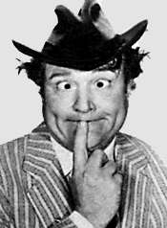 |  | 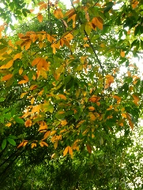
OCTOBER
2017

