SUNDAY | MONDAY | TUESDAY | WEDNESDAY | THURSDAY | FRIDAY | SATURDAY
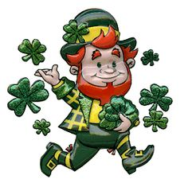 | 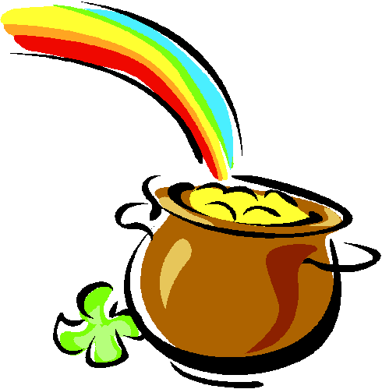 | 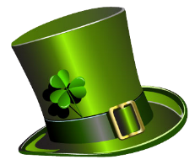 |  | 1  10:15 Exercise  11:00 Carpet Bowling  1:30 Reno Keno  2:30 Tai Chi | 2 10:00 Mental Aerobics  1:30 Noodle Hcky  2:30 Happy Hours | 3  10:15 Exercise  11:00 Carpet Bowling  2:00 Left Right Center  7:00 Bingo
4  10:15 Sandbag Toss  1:00 Communion  1:30 Mental Aerobics  2:30 Church | 5 9:45 Bowling at Scottsdale Lanes  2:30 Video Memories  3:45 Left Right Center  4:00 Bocce Ball | 6 Massage  9:30 Eddie the Dog  10:15 Exercise Bwlg  12:30 Fashion Closet  1:30 Walk & Roll  3:00 Readings  4:00 Bocce Ball | 7 9:30 Painting All Day  4:00 Relax Colouring  7:00 Bingo | 8  10:15 Exercise  11:00 Carpet Bowling  1:30 Reno Keno  2:30 Tai Chi | 9 10:15 Mental Aerobics  10:30 Communion  11:30 Lunch at the Espresso Café  1:30 Noodle Hcky  2:30 Happy Hours | 10  10:15 Exercise  11:00 Carpet Bowling  2:00 Left Right Center  7:00 Bingo
11  10:15 Sandbag Toss  1:30 Mental Aerobics  2:30 Church  TIME CHANGE FORWARD ONE HOUR! | 12 10:30 Denture Presentation & Clinic – 2Fit Denture - Ranj  1:30 Video Memories  3:30 Left Right Center  4:00 Bocce Ball | 13 Massage  9:30 Eddie the Dog  10:15 Exercise Bwlg  1:30 Walk & Roll  3:00 Readings  4:00 Bocce Ball | 14 10:00 Surrey Museum & Lunch in Cloverdale  2:30 Birthday Party with Barry Powel  7:00 Bingo | 15  10:15 Exercise  11:00 Carpet Bowling  1:30 Reno Keno  2:30 Tai Chi | 16 9:30 Mental Aerobics  10:45 Dublin Crossing Pub – Irish Lunch!  1:30 Noodle Hcky  2:30 Happy Hours | 17 ST. PATRICK’S DAY  10:15 Exercise  11:00 Carpet Bowling  2:00 Left Right Center  7:00 Bingo
18  10:15 Sandbag Toss  1:00 Communion  1:30 Mental Aerobics  2:30 Church | 19 9:45 Bowling at Scottsdale Lanes  2:00 Video Memories  3:45 Left Right Center  4:00 Bocce Ball | 20 Massage  9:30 Eddie the Dog  10:15 Exercise Bwlig  1:30 Walk & Roll  3:00 Readings  4:00 Bocce Ball | 21 9:00 Absolute Hearing  10:00 Health Corner with Brigita  1:30 Sandbag Toss  2:45 Coffee Klatch  7:00 Bingo | 22  10:15 Exercise  11:00 Carpet Bowling  1:30 Reno Keno  2:30 Tai Chi | 23 9:30 Decorate for Easter  10:45 Lunch at Golden Panda  1:30 Noodle Hcky  2:30 Happy Hours with Carl | 24  10:15 Exercise  11:00 Carpet Bowling  2:00 Left Right Center  7:00 Bingo
25  10:15 Sandbag Toss  1:00 Communion  1:30 Mental Aerobics  2:30 Church | 26 9:30 Board Games Day!  3:45 Left Right Center  4:00 Bocce Ball | 27 Massage  9:30 Eddie the Dog  10:15 Exercise Bwlg  1:30 Walk & Roll  3:00 Readings  4:00 Bocce Ball | 28` 10:00 Massage  10:45 C-Lovers  1:30 Sandbag Toss  2:45 Relaxation Colouring  7:00 Bingo | 29 10:15 Exercise  11:00 Carpet Bowling  1:30 Reno Keno  2:30 Tai Chi | 30 GOOD FRIDAY  2:00 Children from Celebration Life Church | 31  10:15 Exercise  11:00 Carpet Bowling  2:00 Left Right Center  7:00 Bingo
MARCH
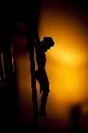2 0 1 8

